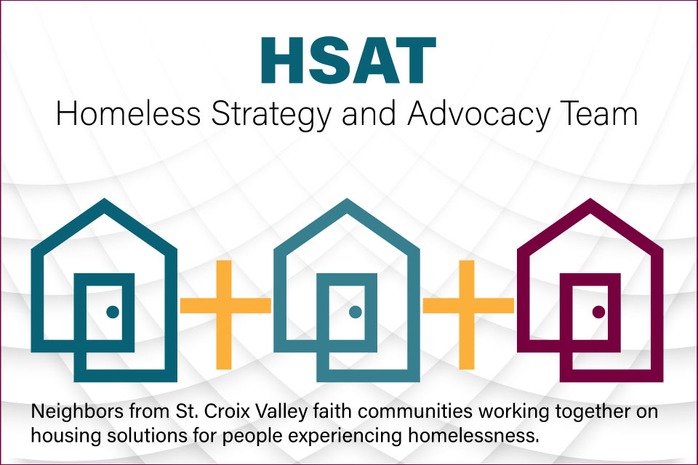
Homelessness is a major issue in the United States and affects people in the Twin Cities including those in Washington County and the St. Croix Valley. It’s estimated that on any given night there are around 7,000 people that are homeless in the Twin Cities. This due to a lack of affordable housing and the COVID-19 outbreak has aggravated the situation.
The Homeless Strategy and Advocacy Team (HSAT) is a collaboration of church members from numerous congregations in the St. Croix Valley and throughout Washington county, that are working to reduce homelessness. The team’s objectives are:
- educate the community regarding the condition of its homeless neighbors.
- identify homelessness mitigating solutions.
- collaboratively advocate by rallying faith community, secular community, and government support that enable homelessness solution implementation.
- and actively implement solutions for homelessness that improve our neighbors’ lives.
Examples of HSAT work includes educating communities that homeless people, though hidden, live amongst them; assembling ‘hygiene kits’ that the Washington County HOST can provide the homeless; advocating for homeless solutions and cooperating with Washington County as it works on implementing a ‘services rich’ homeless shelter; and raising funds to construct a Tiny Home to be in a Sacred Settlement for the homeless.
The HSAT is not restricted to the faith community. Any organization, policy maker, government official or individual working to reduce homelessness is welcome. Many hands, hearts and minds are needed to solve this problem.
For additional information, contact:
John Hodler, 651 343 4638, johnhodler@gmail.com
Jeff Anderson, 651 491 9280, jeffa409@gmail.com

